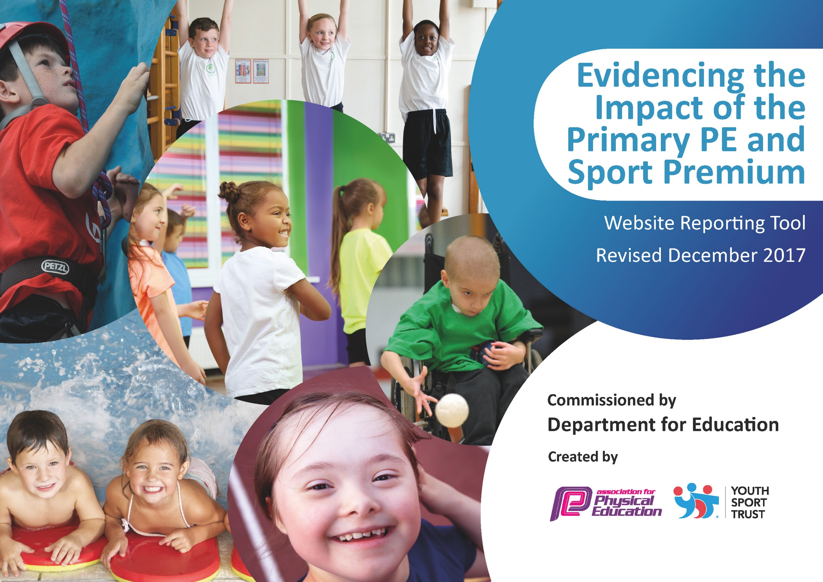

Meeting national curriculum requirements for swimming and water safety | Please complete all of the below*:
What percentage of your current Year 6 cohort swim competently, confidently and proficiently over a distance of at least 25 metres? | 74%
What percentage of your current Year 6 cohort use a range of strokes effectively [for example, front crawl, backstroke and breaststroke]? | 74%
What percentage of your current Year 6 cohort perform safe self-rescue in different water-based situations? | 74%
Schools can choose to use the Primary PE and Sport Premium to provide additional provision for swimming but this must be for activity over and above the national curriculum requirements. Have you used it in this way? | Yes/No

Academic Year: 2019/20 | Total fund allocated: £ | Date Updated: 3.12.19
Key indicator 1: The engagement of all pupils in regular physical activity – Chief Medical Officer guidelines recommend that primary school children undertake at least 30 minutes of physical activity a day in school |  |  |  | Percentage of total allocation:
School focus with clarity on intended impact on pupils: | Actions to achieve: | Funding allocated: | Evidence and impact: | Sustainability and suggested next steps:
To encourage regular physical activity of all pupils in school. | Climbing handgrips to be installed on the walls of both KS1 and KS2 playgrounds. This will give children an alternative to other playtime equipment.
Key indicator 2: The profile of PE and sport being raised across the school as a tool for whole school improvement |  |  |  | Percentage of total allocation:
 |  |  |  | %
School focus with clarity on intended impact on pupils: | Actions to achieve: | Funding allocated: | Evidence and impact: | Sustainability and suggested next steps:

Key indicator 3: Increased confidence, knowledge and skills of all staff in teaching PE and sport |  |  |  | Percentage of total allocation:
 |  |  |  | %
School focus with clarity on intended  impact on pupils: | Actions to achieve: | Funding  allocated: | Evidence and impact: | Sustainability and suggested  next steps:
To increase the confidence, knowledge and skills of staff in teaching gymnastics and dance in PE.  Children will be taught excellent all the gymnastics skills and knowledge required to cover national curriculum requirements to a high standard.  To increase the confidence, knowledge and skills of staff in teaching OAA in KS2. Children will be taught skills and knowledge required to cover national curriculum requirements to a high standard. | Gymnastics equipment will be bought for the hall.  Gymnastics/ Dance training to be brought in and delivered during staff meetings.  JS to attend a training course on Outdoor Adventurous Activity.  JS to feedback key points to staff.  Outdoor Orienteering Mapping to be bought by the school to encourage outdoor learning.  Orienteering posts to be permanently fixed to the outdoor positions within school grounds.
Key indicator 4: Broader experience of a range of sports and activities offered to all pupils |  |  |  | Percentage of total allocation:
 |  |  |  | %
School focus with clarity on intended  impact on pupils: | Actions to achieve: | Funding  allocated: | Evidence and impact: | Sustainability and suggested  next steps:
Children will be taught high quality PE lessons using a wider range of Sports as a tool. | A range of clubs to be put on by teaching staff and outside agencies, including PNE and Judo Education.  New equipment storage to be bought for KS2 playground. This will allow for quicker access to equipment needed for PE lessons. Children will benefit from this as it will ensure they are being taught a wider range of sports/skills.
Key indicator 5: Increased participation in competitive sport |  |  |  | Percentage of total allocation:
 |  |  |  | %
School focus with clarity on intended  impact on pupils: | Actions to achieve: | Funding  allocated: | Evidence and impact: | Sustainability and suggested  next steps:
Children to be given the opportunity to compete for school in a wide range of sports | The school to enter all sports events available through the PESSPA.

